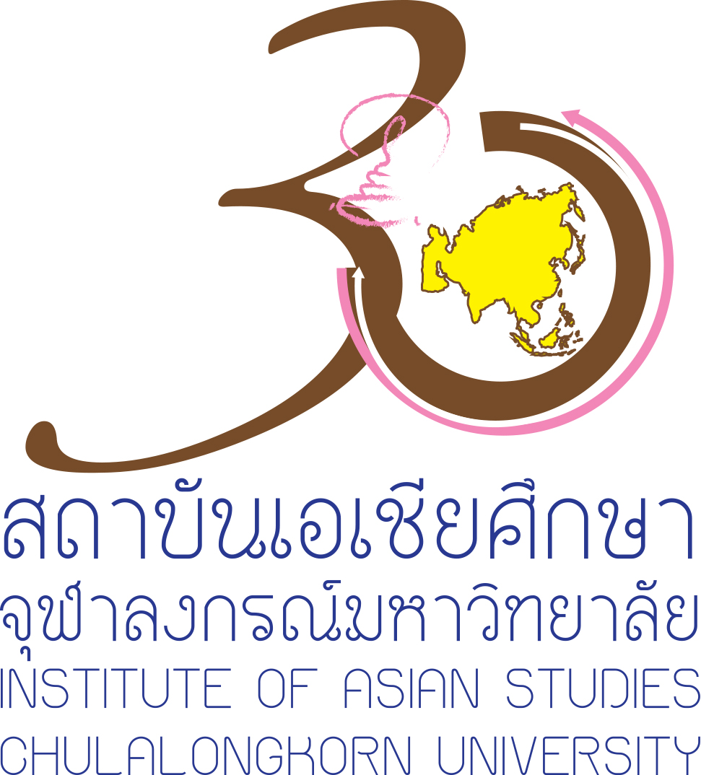
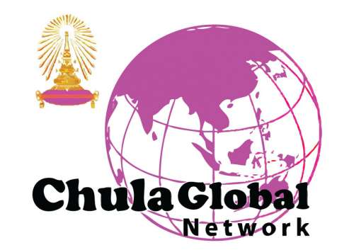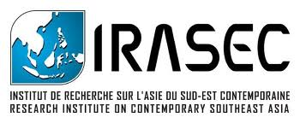

International Seminar on
“Writing History and Correcting Sources: the Building of a National Identity in the Sultanate of Brunei”
Organized by
Chula Global Network, Institute of Asian Studies, Chulalongkorn University
and Research Institute on Contemporary Southeast Asia (IRASEC)

Tuesday 16 June, 2015
Jumpot-Pantip room, 4th floor of Prajadhipok-Rambhai Barni building, Chulalongkorn University

8.30 - 9.00: Registration and Refreshments
9.00 - 9.15: Opening Session
by Assoc. Prof. Dr. Nualnoi Treerat
Director, Institute of Asian Studies, Chulalongkorn University
by Dr. Francois Robinne
Director, Research Institute on Contemporary Southeast Asia
9.15 - 11.00: Brunei: From the Age of Commerce to the 21st Century
by Prof. Dr. Marie-Sybille de Vienne
National Institute for Oriental Languages and Civilisations (INALCO), Paris
Discussants
- Dr. Srawut Aree
Deputy Director, Muslim Studies Center, Chulalongkorn University
- Dr. Jérémy Jammes
Institute of Asian Studies, University of Brunei
Moderator by Mr. Ukrist Pathmanand
Deputy Director, Institute of Asian Studies, Chulalongkorn University
11.00 - 12.00: Open the floor for discussion

