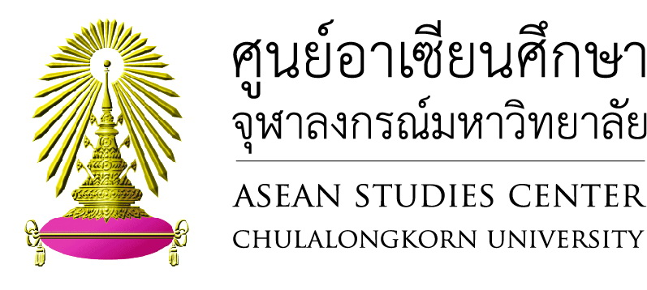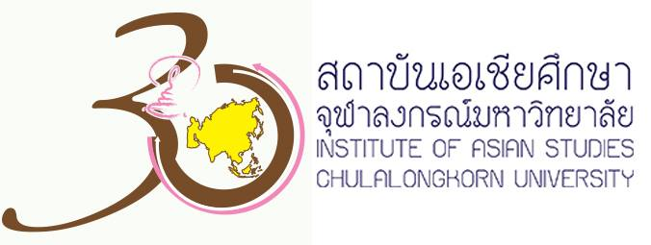

**International Conference on**

**Japan-ASEAN Business and Cultural Relations**

**September 2, 2015 at Chulalongkorn University**

*Organized by*

*ASEAN Studies Center and Institute of Asian Studies, Chulalongkorn University*

*The Japan Foundation*

**Rationale**

Twenty-first century is the time when international relations have changed their shapes. The world becomes increasingly multilateral where information technology has been rapidly developed and every part of the world has been interconnected and interrelated. The borderline between each state has become thinner, and so as the border between government and private affairs. People-to-people relations have indisputably intensified. It has even formed the core of another aspect of diplomacy. Linkage between business and cultural sectors are taking the lead in this context. Its significant in international relations has increased to the point that every government cannot ignore. However, academic research in this field has not been sufficiently conducted.

While relationship between Japan and Southeast Asian countries has flourished for over hundreds years, it has focused mainly on economic cooperation, at government-to-government level of relations. Through those years, business relations have grown and along came cultural relations. Nowadays business and cultural relations have taken a larger share in our partnership. Nevertheless, the role of the governments has not subsided. As ASEAN is coming closer as one community, we have to cooperate more with larger partners of Asia, such as, Japan, China and Korea. Japan is the best study case in term of business and cultural relations due to its long involvement in this region. It is undeniable that Japanese culture introduced through our economic cooperation, such as, Doraemon cartoon, has somehow created common experience among Japanese and ASEAN people. Japan has, thus, contributed greatly to the unity of ASEAN as a regional grouping. In organizing this international conference, we wish that information and knowledge gained from this conference will allow us to understand deeper into this aspect of Japan-ASEAN relationship.

**Participants:** government officials, academic community, students and the general public.

Approximately 50 persons

**Date:** September 2nd, 2015

**Venue:** Maha Chulalongkorn Building,Rm.105

**Schedule:**

08.30 – 09.00 Registration

09.00 – 09.30 Opening ceremony

09.30 – 10.15 Keynote speech on “Japan-ASEAN Strategic Partnership in the 21 Century”

By Professor Yuji Suzuki, PhD, Hosei University

10.15 – 10.30 tea/coffee break

10.30 – 11.30 “Business Sector in Japan-ASEAN Relations”

By Professor Tri Widodo, PhD, Gadjahmada University

11.30 – 12.30 Discussant

By Assistant Professor Piti Srisangnam, PhD, Chulalongkorn University

------------------------------------------

Lunch break

------------------------------------------

13.30 – 14.30 Media and Cultural Influence in Japan-ASEAN Relations

By Professor Koichi Iwabuchi, PhD, Monash University

14.30 – 14.45 tea/coffee break

14.45 – 15.45 Discussant

By Supaporn Phokaew, Chulalongkorn University.



**Reply Form**

**“Japan-ASEAN Business and Cultural Relations”**

By

ASEAN Studies Center and Institute of Asian Studies, Chulalongkorn University

The Japan Foundation

September 2nd, 2015, 8.30 am. – 15.45 pm.

Room105, Maha Chulalongkorn Building,Chulalongkorn University

**\*\*\*\*\*\*\*\*\*\*\*\*\*\*\*\*\*\*\*\*\*\*\*\*\*\*\*\*\*\*\*\*\*\*\*\*\*\*\*\*\*\*\*\*\*\*\*\*\*\*\*\*\*\*\*\*\*\*\*\*\*\*\*\*\*\*\*\*\*\*\***

Name……………………………………………………………………………………….

Surname…………………………………………………………………………………….

Title…………………………………………………………………………………………

Institution…………………………………………………………………………………..

E-mail………………………………………………………………………………………

**RSVP:** Email [myresearch7@gmail.com](mailto:myresearch7@gmail.com)

For more information, please call tel.no 0-2218-7464.

