 | 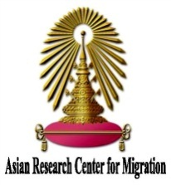 |  |  | 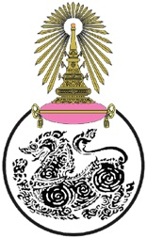
Registration Form
International Migrants Day’ Conference on “Harmonizing Migration Networks: In Search of Inclusive and Sustainable Solution”
Tuesday 20 December 2016: 08h30-18h00
Faculty of Political Science Main Auditorium, 13th Floor, Chulalongkorn University

1. Organization name
Address
Tel. Fax
2. Participant name (s):
2.1 Name (Mr./Mrs/Ms/other) Role/Position Phone number
Email:

2.2 Name (Mr./Mrs/Ms/other) Role/Position Phone number
Email:

3. Sub-Theme (Kindly select one sub-theme that you are most interested)

3.1 Human Trafficking and People Smuggling
3.2 Displaced Person/Refugee/Asylum Seekers
3.3 Labour Migration

Please register and submit this form before Friday9th December2016 to the Asian Research Center for Migration (ARCM) at the Institution of Asian Studies, Chulalongkorn University.
Either by fax: 0-2218-7419, or e-mail at arcmthailand.chula@gmail.com
Thank you very much.

